create a folder aman and aditya

inside aman folder create three files

copy the first file from aman to aditya

move the second file from aman to aditya

copy the third file into aditya but new name

copy aman folder to aditya

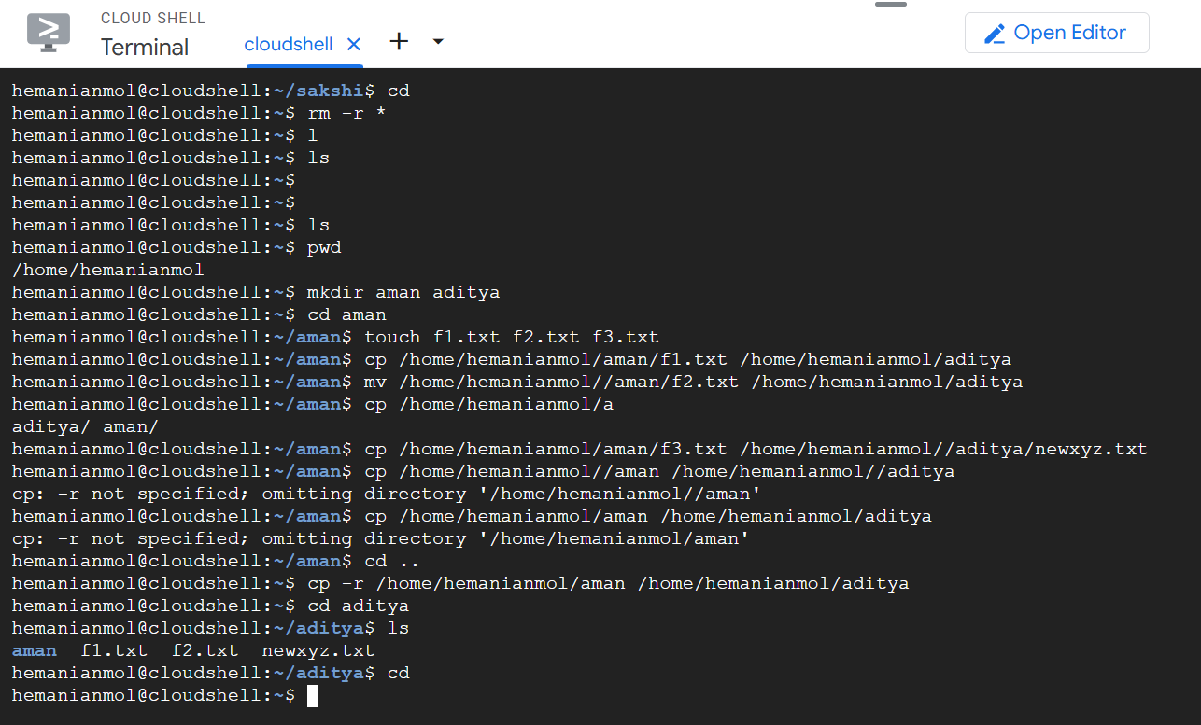

* Tar command and how it is different from zip file.